EXPERIMENT

**AIM:** To design an automatic night lightening system (with 4 connected led’s)such the system is only activated when the master control switch is pressed. A) Below 50% value of full brightness all led’s constantly ON. B) Above 50% value of full brightness only first LED is ON.

**APPARATUS:**Arduino,resistor(10K,22O),wire ,breadboard,LED.

**CIRCUIT DIAGRAM:**

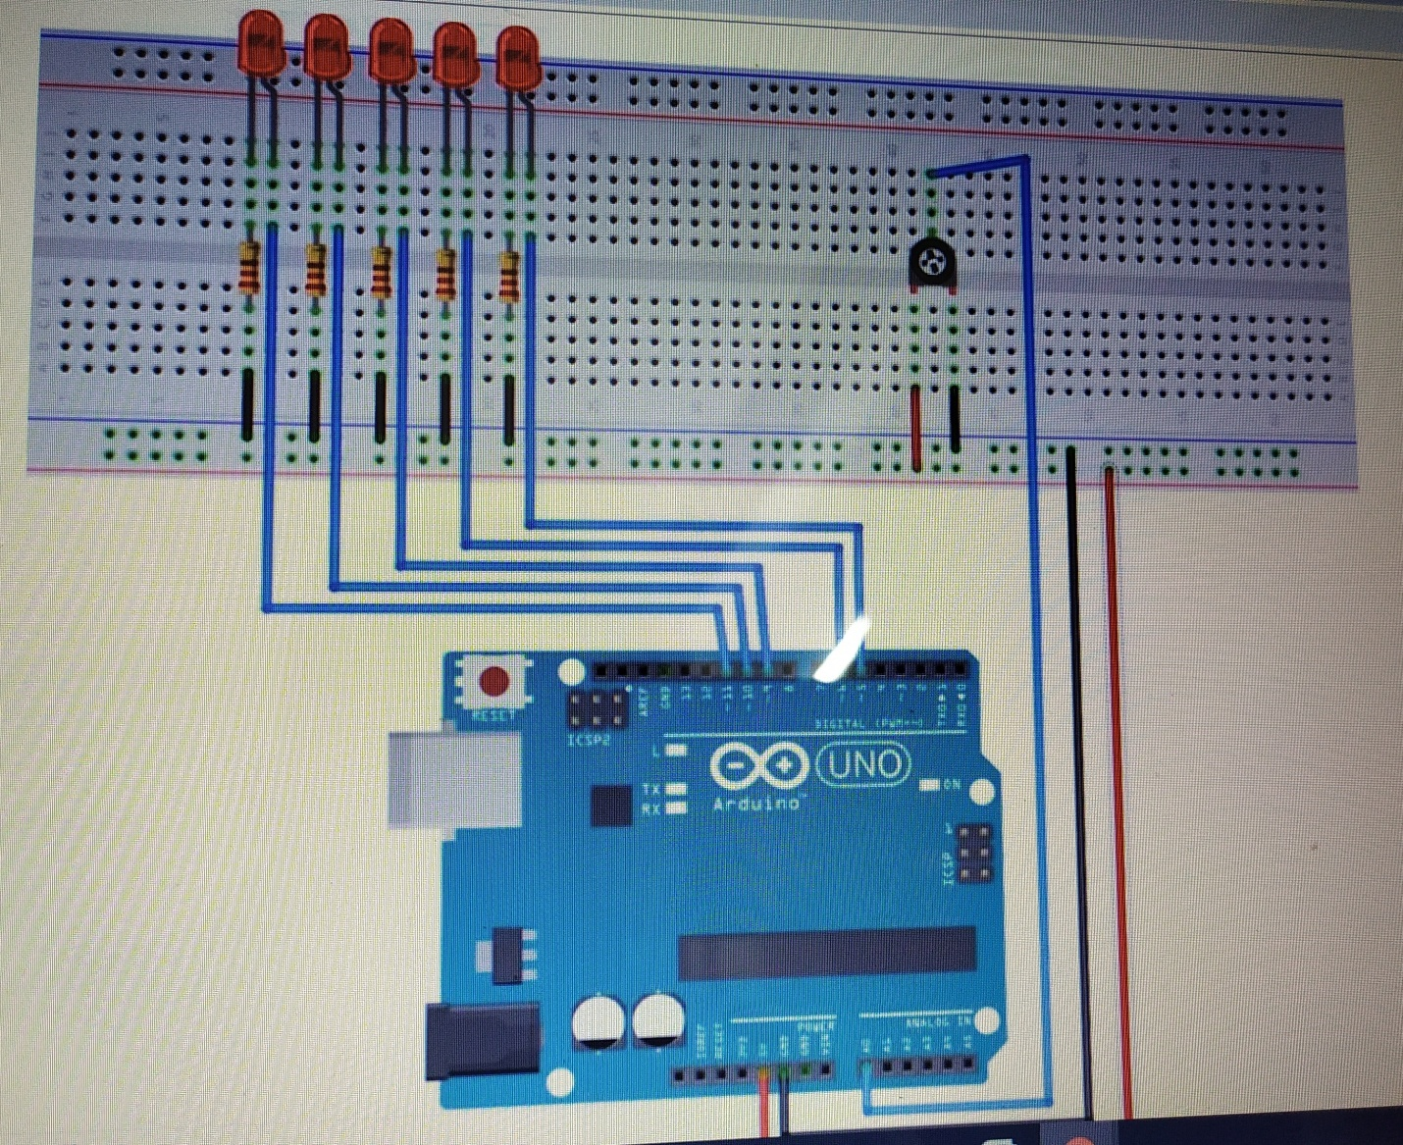

**PROGRAM:**

const int ledPin = 8;

const int ledPin =10;

const int ledPin =12;

const int ledPin =14

const int ldrPin = A0;

void setup() {

Serial.begin(9600);

pinMode(ledPin, OUTPUT);

pinMode(ldrPin, INPUT);

}

void loop() {

int ldrStatus = analogRead(ldrPin);

if (ldrStatus <=300) {

digitalWrite(ledPin , HIGH );

Serial.println("LDR is DARK, LED is ON");

}

else {

digitalWrite(ledPin, LOW);

Serial.println("");

}

}

**RESULT:**

system is activated when the master control switch is pressed. A) Below 50% value of full brightness all led’s constantly ON. B) Above 50% value of full brightness only first LED is ON.